**Pico CTF Challenge**

**UnMinify**

**(Pathway)**

**Challenge 1 : Unminify**

**Category :** Web Exploitation

**Difficulty :**  Easy

**Description :** I don't like scrolling down to read the code of my website, so I've squished it. As a bonus, my pages load faster!

Additional details will be available after launching your challenge instance.

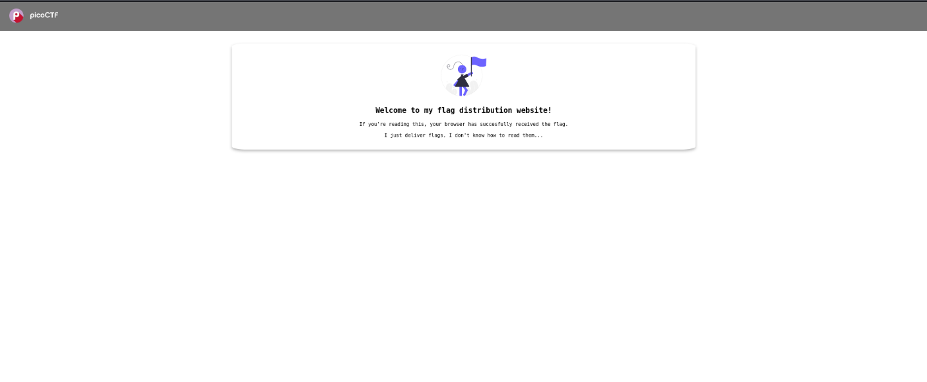 Analyse the web Page

No information available in the webpage, let’s find something on the Inspect of the webpage.

After Inspecting web page also No Clue found

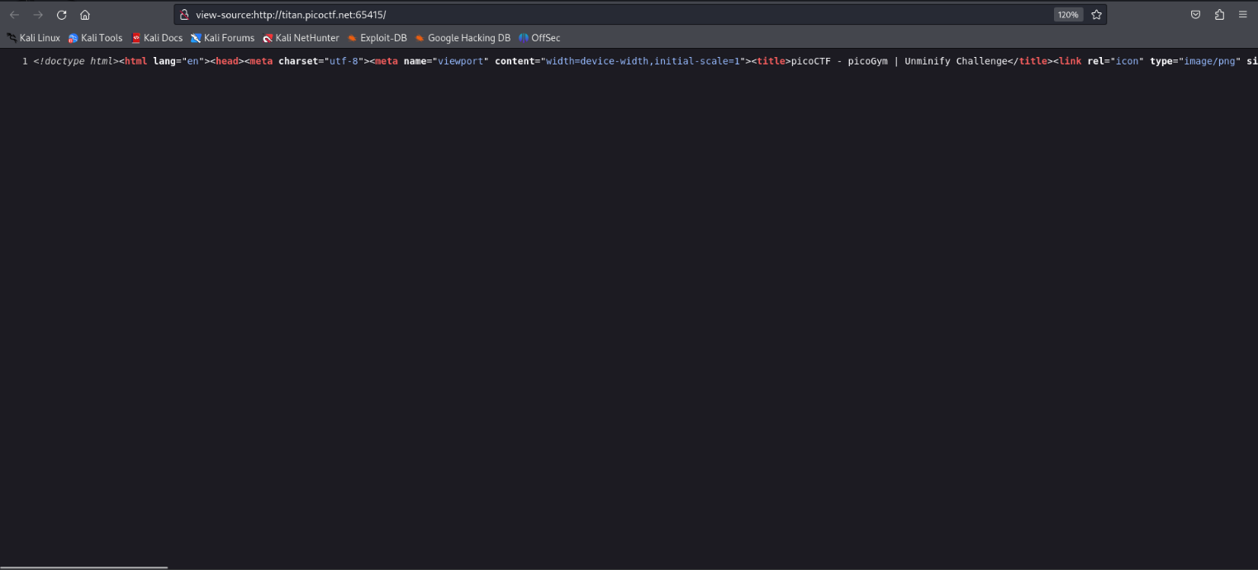Let’s find Something on the page source

Page source look like this !!, So it’s very hard to find the Flag, So we should Search for the Flag by Entering Ctrl+F key and enter “Picoctf”.

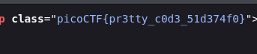

Here is the flag